Gorge Fly Shop  3200 Lower Mill Dr.  Hood River, OR 97031  Gear “Trade Up” Form |  | www.gorgeflyshop.com  info@gorgeflyshop.com  541.386.6977 |  | 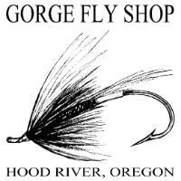
Name:
Address: |  |  | Apartment/Unit:
City: |  |  | State:
Country: |  |  | Province:
Email: |  |  | Phone:

Trade Up:
Describe the condition of your product(s) (i.e., scratches, fading, etc.):
What item is your trade-in quote for?
Terms:
(Please Read Carefully) - We generally prefer fly rod and reels as trade in items, but we will consider any fly-fishing gear for trade but reserve the right to refuse anything for any reason. Keep in mind that used gear is only worth what the current market will pay regardless of what you paid for it. Final determined value can only be made upon inspection of your equipment.

Customer is responsible for shipping items to us (We recommend a reliable insured method).
Customer is responsible for a filled in Trade-in form. No item will be considered without this form. If no decision can be reached, the customer will be responsible for the actual return shipping cost.
Items we will not consider – Used waders, used boots, used fly lines and any heavily worn or abused items.
List Item(s) you wish to trade: |  | Trade in Quotes
Signature:
I certify that my information is true and complete to the best of my knowledge.
Signature: |  | Date:

